# DATA ENGINEER TRAINING ASSIGNMENT-1

**DATA WAREHOUSE:**



A data warehouse is a large digital storage system used by businesses to collect and store information from different sources. Imagine it like a big library, but instead of books, it stores data—lots of it.

Companies gather data every day from things like:  
- Sales  
- Customer support  
- Marketing  
- Website activity  
- Social media

But all this data comes in different formats and from different places. A data warehouse helps bring all that information together in one clean, organized, and consistent format so it can be used easily.

Unlike regular databases that help run daily operations (like processing orders), a data warehouse is mainly used to analyze data. It helps people in a company understand trends, make decisions, and plan better.

For example:  
- A retail company might use a data warehouse to look at customer buying habits.  
- A hospital might use one to analyze patient treatment results.  
- A bank might use it to detect unusual spending patterns.

**WORKING OF DATA WAREHOUSE:**.

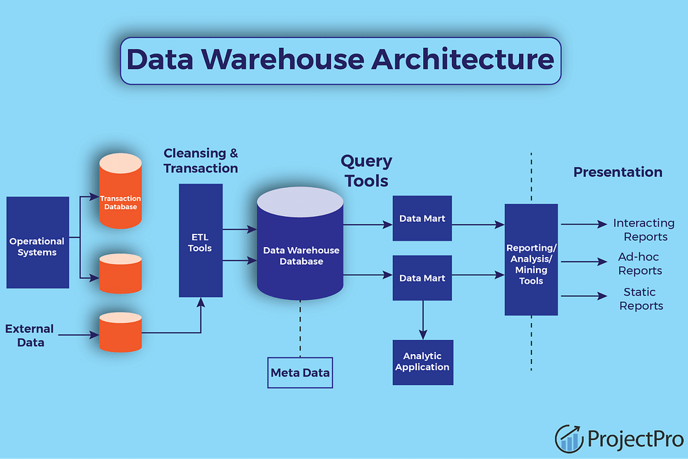

A data warehouse works by collecting, cleaning, and organizing data from different places. Here’s a simple step-by-step process:

1. Data Collection:  
Data comes from many sources:  
- Online forms  
- Sales systems (like cash registers)  
- Apps  
- External tools (like Google Analytics)

This raw data is gathered using tools called ETL tools. ETL stands for:  
- Extract – Pull the data from the source.  
- Transform – Clean and reformat the data so it fits.  
- Load – Store it in the data warehouse.

2. Storage:  
Once the data is loaded, it is stored in organized “tables” inside the warehouse. Think of these as spreadsheets that are connected and easy to search.

3. Access and Use:  
Employees like data analysts, marketers, or executives can use special tools to:  
- Run reports (e.g., “How many sales did we make last week?”)  
- Spot trends (e.g., “What products are most popular in December?”)  
- Predict future behavior (e.g., “What will customers buy next month?”)

These insights help businesses grow, avoid risks, and improve performance.

**BENEFITS:**

Using a data warehouse gives many advantages to businesses.

1. Better Decision-Making:  
When all your data is in one place and easy to understand, you can make smarter choices.

2. Saves Time:  
Instead of digging through separate systems for information, everything is already collected and ready to analyze.

3. Improved Data Quality:  
Since the data goes through a cleaning process, it’s more accurate and reliable.

4. Historical Analysis:  
A data warehouse stores data over time, so you can look back at trends from last month, last year, or even five years ago.

5. Security and Control:  
Modern data warehouses come with strong security tools to protect sensitive data.

6. Scalability:  
As your business grows and your data increases, the warehouse can grow with it. Cloud-based data warehouses like Snowflake or Amazon Redshift can handle huge amounts of information without slowing down.

**REAL-LIFE EXAMPLES:**

Retail:  
A clothing store chain collects sales data from hundreds of locations. The data warehouse combines it all to help decide:  
- Which stores need more stock  
- Which items are bestsellers  
- What promotions work best

Healthcare:  
Hospitals store patient data in a warehouse to:  
- Monitor health trends  
- Track the success of treatments  
- Improve patient care and reduce costs

Finance:  
Banks use data warehouses to:  
- Track transactions  
- Spot fraud patterns  
- Provide better customer service